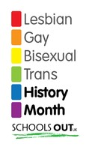
Homework- Tone of Voice

Nobody wants to spend much time watching TV or movies, but sometimes we all just have to do things that will be for our benefit in the long run :0)
For this homework, while you’re watching, listen out for examples of dialogue, where the way an actresss or actor says a line has a huge impact on the drama you’re watching.
Soaps and hospital dramas are particularly useful for this, but there will be plenty of examples in any drama.
The most important part of this homework is explaining how the way a line is said affects what’s happening. Be as precise as you can be with this.
Copy the grid into your book or on your paper. There isn’t enough room to do this properly on this sheet.
Happy viewing!
Programme/Movie | Name of character | What they said | How they said it  (use an adverb) | Effect on the drama
Holby City | Charlie’s Mum | ‘Look at my boy.’ | pleadingly | The viewer knows immediately she thinks it’s a serious problem.

